LONDON POLICE DEPARTMENT

Employment Application

The application and selection process include many steps designed to examine the applicants abilities and interest in Law Enforcement. The following information is provided so that you may know the requirements and what is expected of you as the applicant.

REQUIREMENTS:

- Must be a U.S. Citizen
- Must be 21 years of age
- Must have a High School Diploma, or its equivalent
- Must have a Valid Driver’s License
- Must have read and signed the KLEC Code of Ethics form
- Must have read and signed the KLEC Cannon of Ethics form
- Must have not been convicted of a Felony or have any criminal action pending
- Must not have received a dishonorable discharge or general discharge under other than honorable conditions from any branch of service of the United States Armed Forces
- Must not have had a certification as a Police Officer revoked in this state or another state
- Must not have bought, sold or possessed marijuana within three (3) years prior to time of application
- Must not have bought, sold or possessed any controlled substance or narcotic drug without a prescription within six (6) years prior to time of application
- Must not be prohibited by Federal or State Law form possessing a firearm
- Misdemeanor convictions will be considered on an individual basis
- Must submit fingerprints for a criminal background check
- Must submit to and pass a medical examination
- Must submit to a drug screen test
- Must submit to a polygraph examination
- Must pass an in-depth background investigation
- Must pass a written pre-employment test
- Must be willing to work a varied work schedule
- Must be able to pass physical fitness standards
- Must bench press 64% of your body weight
- Must complete 18 sit-ups within 1 minute
- Must complete 20 push-ups in 2 minutes
- Must run 300 meters in 65 seconds
- Must run 1.5 miles in 17 minutes and 12 seconds
- Must complete an oral interview if selected in the top % of the applicants

All applicants must meet the above stated minimum requirements. Those who do not meet the minimum requirements will be disqualified from the process.

The City of London is an Equal Opportunity Employer

Required Documentation:

The following is a list of documents which MUST accompany the application upon submission. It is the responsibility of the applicant to obtain, copy, and submit the following. Failure to provide required documents will disqualify the applicant.

- Driver’s License. All copies must be viewable and readable.
- Birth Certificate
- High School Diploma. (High School transcript is acceptable if it shows applicant’s graduation date.)
- DD214 if former Military.
- Military ID card showing enlistment date and current rank if currently on active duty with the Military Reserves, or National Guard.
- Signed Authority to Release Information form.
- Training Certificate, if a Certified Peace Officer.
- Signed copy of KLEC Code of Ethics.
- Signed copy of KLEC Cannon of Ethics.

ACCEPTABLE FORMS OF VERIFICATION
Education:

The Kentucky Enforcement Council requires that prospective police recruits verify high school education or GED using copies of one of the following documents:
- High School Diploma (pocket diplomas are NOT acceptable to verify High School Education).
- High School Transcript (must be signed and dated; must specify date graduated and rank in class).
- Letter from Board of Education verifying High School Education.
- GED Certificate from an approved State Department of Education with a certificate number affixed to the certificate, if applicable in your state.

Birth Date:

A copy of one of the following documents is necessary to verify your age.
- Birth Certificate
- Passport
Note: If you are hired you MUST submit a certified birth certificate to the London Police Department.

Valid Driver’s License:

- You must have a valid driver’s license at the time of testing.

Military:

- If former Military, you must submit a copy of your DD214, which includes your dates of service and any disciplinary actions taken against you.
- If current Military, Reserves, or National Guard, you must submit a copy of your Military ID Card which shows your current rank and enlistment date.

SELECTION PROCESS

Review of Application:

After applications have been received, and the employment application process date has closed, each application will be reviewed to ensure each applicant meets minimum qualifications, and has provided the required documents, with the application.

It is the responsibility of the applicant to be honest and to provide accurate information on the employment application. Failure to be forthcoming may result in disqualification of the application.

Pre-Employment Written Ezam and Pre-Employment Physical Ability Test

Once the application review has been completed, all qualified applicants will be notified of the date, time, and location to complete both the pre-employment written examination consisting of reading comprehension and reasoning ability and a pre-employment physical ability test. Upon examiner’s request, applicants must be able to provide a current driver’s license at the time of testing. Applicants who have passed the written exam with a minimum score of 70 percent will be tested for their physical ability. This test will be scheduled at the Department of Criminal Justice Training facility located in Richmond, Ky. Each applicant can find the physical agility requirement at docjt.jus.state.ky.us. It is most important to begin conditioning yourself for testing. Applicants who have completed both the written and physical testing phase will be notified of your placement in the hiring process. If successful, applicant will be assigned an investigator and be moved to the Background Investigation Phase.

Background Investigation Phase

Background investigators from the London Police Department will verify all information provided in the application, including as well as conduct the following:

- One-on-One interview with the applicant
- Interview with family members
- Reference checks
- Interview with co-workers

Oral Exam:

Applicants who successfully complete the background investigation phase will be notified and scheduled a date, time, and location for an oral exam.

Eligibility List:

Applicants who have completed the oral examination will be placed on the eligibility list. This list will be reviewed by the London Police Department’s Chief’s Review Board Committee to be considered for a conditional offer of employment.

Potential Reasons for Disqualification of Employment

The following are some, but not limited to, examples of common reasons for disqualification of employment:
- Falsification of background information
- Arrest history
- Drug usage
- Unstable work history
- Misunderstanding of job requirements
- Driving record
- Education
- Immaturity
- Failure to have witnessed both “Authority to Release Information” pages

Address and Contact Information

If your name, address and/or phone number changes after you have submitted your application, or if for any reason you no longer wish to be considered, we ask that you notify Chief Darrel Kilburn or Capt. Randy Medlock. It is extremely important to the application process that you provide us with these changes immediately.

PERSONAL HISTORY

Applicant Information
Full Name: |  |  |  | :
 | Last | First | M.I. |  | .Maiden

Address:
 | Street Address | Apartment/Unit #

 | City | State | ZIP Code
Place of Birth: | City County | State | ZIP Code

Phone: |  | Work:
Cell Phone: |  | Email

Date of Birth: |  |  | Social Security No.: |  |  | Height: ______ |  |  |  | Weight:
Father: |  |  |  |  |  |  |  | :
 | Last |  |  | First |  |  | M.I. |  | .Phone #

Address:
 | Street City County |  |  |  |  | State/Zip
Mother: |  |  |  | :
 | Last | First | M.I. |  | .Phone #

Address:
 | Street City County | State/Zip

Position Applied for:
Marital Status: | Married |  | Divorced | Separated | Widowed | Single

I am a U.S. Citizen by: | Birth | Naturalization (copy of documents required)

Has applicant ever had name legally changed? | YES | NO

If yes:

Previous Name Court of Jurisdiction and Address County

Previous Name Court of Jurisdiction and Address County

If yes, has applicant ever used an alias? |  | YES | NO
If yes, list alias(s) and circumstances of use:

PERSONAL HISTORY (continued)
QUESTIONS FOR APPLICANT:

- Have you ever been convicted of a felony? | YES | NO
- Have you ever had automobile insurance canceled or refused? | YES | NO
- Have you ever been convicted of a felony? | YES | NO
- Have you ever been charged with a crime? | YES | NO
- Have you ever used narcotics, drugs, or marijuana in any illegal manner? | YES | NO
- Have you used marijuana since the age of twenty-one? | YES | NO

If yes, when was the last time you used marijuana?
Month/Year

- Have you ever used any other illegal drugs? | YES | NO
If yes, when was the last time you used illegal drugs?
Month/Year

- Are you willing to reside anywhere in London, Laurel County, Kentucky? | YES | NO
- Have you ever applied for employment at the London Police Department or other police agency? | YES | NO
If yes, when and where?

If you have answered ‘YES’ to questions 1-5, please list the question # and explain below:

Education
High School: |  | Address:
City: |  | County:
Zip:

Secondary Education

College: |  | Address:
City: |  | County:
Zip:

Dates Attended:

From (Month/Year): |  | To: |  | Did you graduate? | YES | NO | If yes, Degree::

Major: Minor:
If no: | Less than 60 college hours | More than 60 college hours | GPA:
Area of concentration:

Other Education

College: |  | Address:
City: |  | County:
Zip:

Dates Attended:

From (Month/Year): |  | To: |  | Did you graduate? | YES | NO | If yes, Degree::

Major: Minor:
If no: | Less than 60 college hours | More than 60 college hours | GPA:
Area of concentration:

Education (continued)

Is English the applicant’s primary language? | YES | NO
Does applicant speak a secondary language? | YES | NO
Please check all that apply:
 | English | Spanish
 | French | Japanese
 | Sign Language | Other List:

Computer | Please check all that apply:  Windows  Word  Excel  Powerpoint  Other:_________________________________________
Professional Registrations/Licenses/Certificates | Please check all that apply:  Certified Police Officer  CPR Expiration:_______________________  EMT and/or Paramedic Expiration:________________  Powerpoint  Other:_________________________________________
Other Training

TRAFFIC/CRIMINAL

Total number of points against driving record: _____________ As of: _____________
DATE CHECKED

List ALL traffic citations received even if dismissed:

DATE | CHARGES | COUNTY AND STATE | DISPOSITION
DATE | CHARGES | COUNTY AND STATE | DISPOSITION
DATE | CHARGES | COUNTY AND STATE | DISPOSITION
DATE | CHARGES | COUNTY AND STATE | DISPOSITION
DATE | CHARGES | COUNTY AND STATE | DISPOSITION

List ANY traffic or criminal arrests:

DATE | CHARGES | COUNTY AND STATE | DISPOSITION
DATE | CHARGES | COUNTY AND STATE | DISPOSITION
DATE | CHARGES | COUNTY AND STATE | DISPOSITION
DATE | CHARGES | COUNTY AND STATE | DISPOSITION
DATE | CHARGES | COUNTY AND STATE | DISPOSITION

Character Reference Report

Please list a minimum of three professional references. Character references cannot be a relative or a city employee.
Full Name: |  |  | Phone:
Company: |  |  | State/Zip:
Address:
Full Name: |  |  | Phone:
Company: |  |  | State/Zip:
Address:
Full Name: |  |  | Phone:
Company: |  |  | State/Zip:
Address:

Previous Employment

Please list in the order of the most current. May we contact your current employer? Yes No

Employer: |  | Phone:
Address: |  | Supervisor:

Job Title: |  | Starting Salary: | $ | Ending Salary: | $
Week Month Year

Responsibilities:

From: |  | To: |  | Reason for Leaving:

May we contact your previous supervisor for a reference? | YES | NO

Employer: |  | Phone:
Address: |  | Supervisor:

Job Title: |  | Starting Salary: | $ | Ending Salary: | $
Week Month Year

Responsibilities:

From: |  | To: |  | Reason for Leaving:

May we contact your previous supervisor for a reference? | YES | NO

Employer: |  | Phone:
Address: |  | Supervisor:

Job Title: |  | Starting Salary: | $ | Ending Salary: | $
Week Month Year

Responsibilities:

From: |  | To: |  | Reason for Leaving:

May we contact your previous supervisor for a reference? | YES | NO

Employer: |  | Phone:
Address: |  | Supervisor:

Job Title: |  | Starting Salary: | $ | Ending Salary: | $
Week Month Year

Responsibilities:

From: |  | To: |  | Reason for Leaving:

May we contact your previous supervisor for a reference? | YES | NO

Employer: |  | Phone:
Address: |  | Supervisor:

Job Title: |  | Starting Salary: | $ | Ending Salary: | $
Week Month Year

Responsibilities:

From: |  | To: |  | Reason for Leaving:

May we contact your previous supervisor for a reference? | YES | NO

Military Service
Branch: |  | From: |  | To:

Rank at Discharge: |  | Type of Discharge:

If other than honorable, explain:

Disclaimer and Signature
I certify that my answers are true and complete to the best of my knowledge. I understand that any willful misstatements or material omissions in this application will be sufficient cause to disqualify me from employment consideration with the City of London Police Department. If such misstatements or omissions are found after employment, it will be considered grounds for dismissal. I understand that this completed application and any materials submitted with it are the property of the City of London Police Department and will not be returned regardless if I am offered employment. I understand that any offer of employment is contingent upon my ability to produce documentation required by the Immigration and Naturalization Service documenting eligibility, if necessary, for employment.
I authorize the release of any and all employment related information that the City of London may request or any records pertaining to past or present employment which may now exist or exist in the future.
Signature: |  | Date:

LONDON POLICE DEPARTMENT
AUTHORITY TO RELEASE INFORMATION

I, (Print Name)____________________________________ on, (Date)____________________, having made application for employment with the London Police Department and desiring that they be informed of my personal records pertinent to their investigation, hereby authorize an investigation into all records which may be of interest to them. This authorization includes, but is not limited to, employment, medical, hospital, education, credit records, financial information, military and internal affairs records whether privileged or not.

This authorization is executed in consideration of the London Police Department Personnel Board considering my application and shall serve as a release for all liability to all parties furnishing such information to the Police and their authorized agents.

A photocopy of this release shall be considered as effective and binding as the original hand written executed copy.

WITNESSED BY | APPLICANT SIGNATURE
 | STREET
 | CITY
 | STATE, ZIP CODE

LONDON POLICE DEPARTMENT
AUTHORITY TO RELEASE CREDIT HISTORY INFORMATION

I, (Print Name)____________________________________ on, (Date)____________________, having made application for employment with the London Police Department and desiring that they be informed of my personal records pertinent to their investigation, hereby authorize an investigation into all credit history records which may be of interest to them. Furthermore, I authorize the release of my credit history report upon request, by the Credit Reporting Agency to the London Police Department.

This authorization is executed in consideration of the London Police Department Personnel Board considering my application and shall serve as a release for all liability to all parties furnishing such information to the Police and their authorized agents.

A photocopy of this release shall be considered as effective and binding as the original hand written executed copy.

WITNESSED BY | APPLICANT SIGNATURE
 | STREET
 | CITY
 | STATE, ZIP CODE

The London Police Department certifies that the credit history information obtained will be in compliance with the Fair Credit Reporting Act, 15 USCS Section 1681, et seq., and will not be used in violation of any Federal or State equal opportunity laws.

DO NOT WRITE BELOW THIS LINE. OFFICIAL USE ONLY
Application: | Accepted Denied
Reason for Denial: |  |  | Date:

Reviewed By: |  | Date:

Form L-1 Kentucky Law Enforcement Council
CODE OF ETHICS
Mail: Kentucky Law Enforcement Council  Funderburk Building  521 Lancaster Ave.  Richmond, KY 40475  Phone: (859) 622-6218  Fax: (859) 622-5943 | Instructions: This form must be given to and read by the peace officer applicant prior to being hired. Please have applicant attest to reading the Code of Ethics, at the bottom of the page and place a signed copy in their POPS file

CODE OF ETHICS

As a Peace Officer, my fundamental duty is to serve mankind; to safeguard lives and property; to protect the innocent against deception, the weak against oppression or intimidation, and the peaceful against violence or disorder; and to respect the Constitutional rights of all men to liberty, equality and justice.

I will keep my private life unsullied as an example to all; maintain courageous calm in the face of danger, scorn, or ridicule; develop self-restraint; and be constantly mindful of the welfare of others. Hones in thought and deed in both personal and official life, I will be exemplary in obeying the laws of the land and the regulations of my department. Whatever I see or hear of a confidential nature or that is confined in me in my official capacity will be kept ever secret unless revelation is necessary in the performance of my duty.

I will never act officiously or permit feelings, prejudices, animosities or friendships to influence my decisions. With no compromise for crime and with relentless prosecution of criminals, I will enforce the law courteously and appropriately without fear or favor, malice or ill will, never employing unnecessary force or violence and never accepting gratuities.

I recognize the badge of my office as a symbol of public faith, and I accept it, as a public trust to be held so long as I am true to the ethics of the police service. I will constantly strive to achieve these objectives and ideals, dedicating myself before God to my chose profession – law enforcement.

I attest that I have read and received a copy of the Code of Ethics.

____________________________________ ___________________
Name of Applicant Date

London Police Department

CODE OF ETHICS

As a Peace Officer, my fundamental duty is to serve mankind; to safeguard lives and property; to protect the innocent against deception, the weak against oppression or intimidation, and the peaceful against violence or disorder; and to respect the Constitutional rights of all men to liberty, equality and justice.

I will keep my private life unsullied as an example to all; maintain courageous calm in the face of danger, scorn, or ridicule; develop self-restraint; and be constantly mindful of the welfare of others. Hones in thought and deed in both personal and official life, I will be exemplary in obeying the laws of the land and the regulations of my department. Whatever I see or hear of a confidential nature or that is confided in me in my official capacity will be kept ever secret unless revelation is necessary in the performance of my duty.

I will never act officiously or permit personal feelings, prejudices, animosities or friendships to influence my decisions. With no compromise for crime and with relentless prosecution of criminals, I will enforce the law courteously and appropriately without fear, malice or ill will, never employing unnecessary force or violence and never accepting gratuities.

I recognize the badge of my office as a symbol of public faith, and I accept it, as a public trust to be held so long as I am true to the ethics of the police service. I will constantly strive to achieve these objectives and ideals, dedicating myself before God to my chosen profession – Law Enforcement.

____________________________________ ___________________
Name of Applicant Date

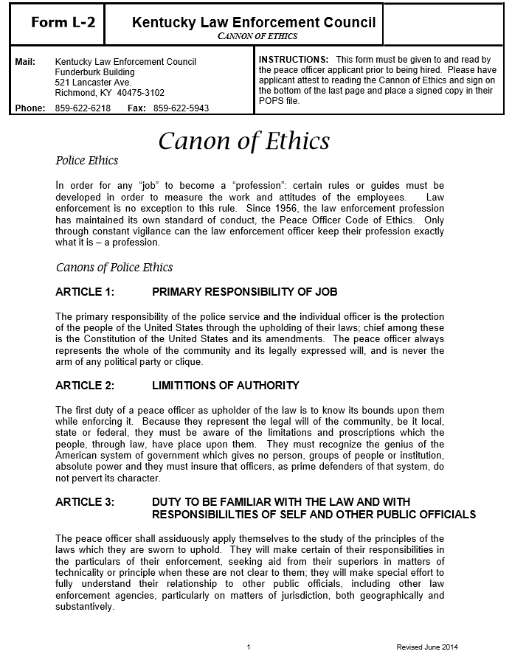

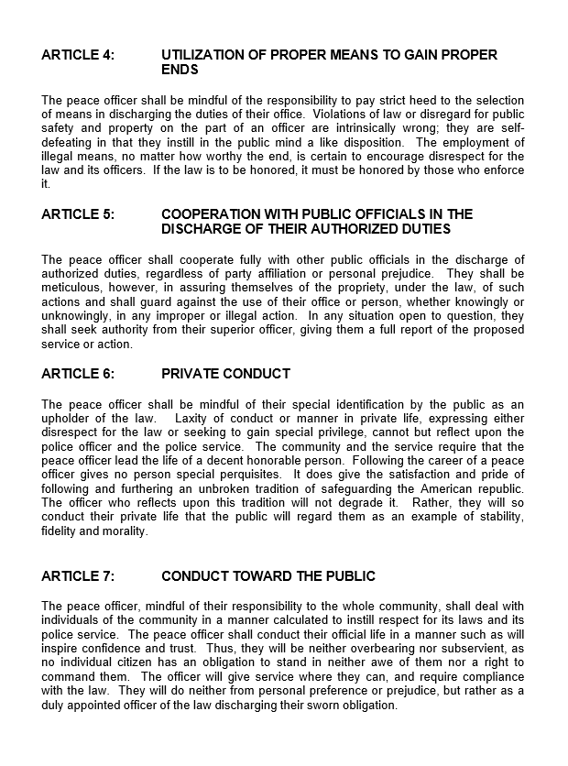

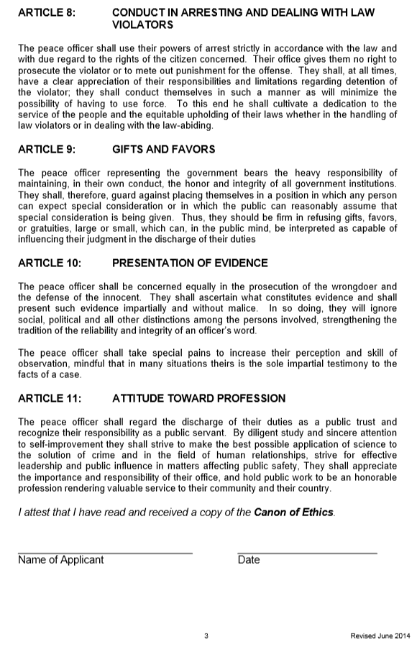

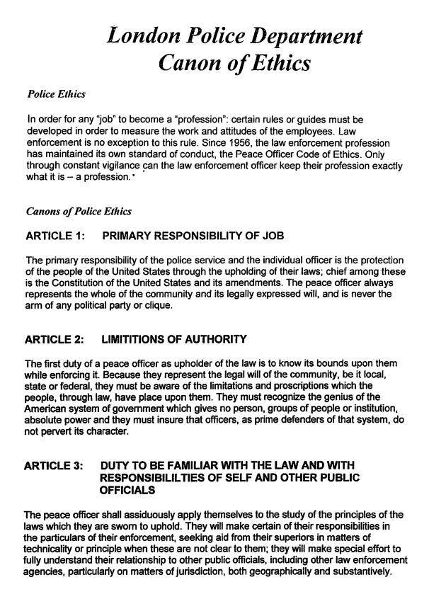

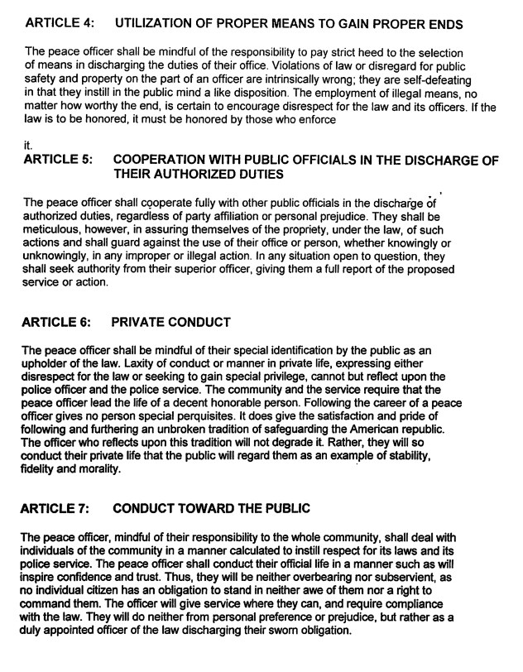

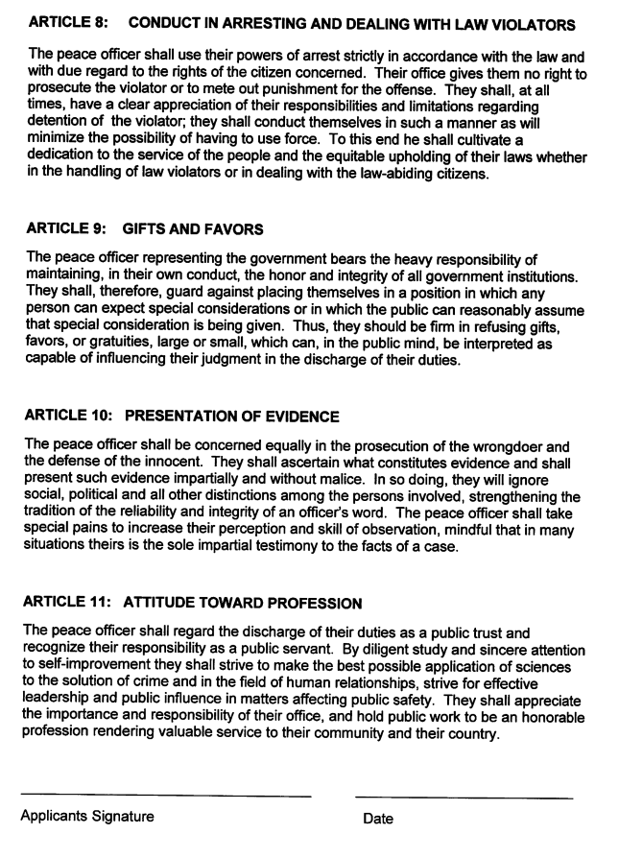

POPS | COMPLIANCE SECTION  PEACE OFFICER PROFESSIONAL STANDARDS CHECKLIST
Department of Criminal Justice Training  Compliance Department  Funderburk Building  521 Lancaster Ave.  Richmond, KY 40475-3102  Phone: (859) 622-5924 | Instructions: This is a copy of a checklist that will be used during an audit conducted by the Compliance Section. Proof of each item must be retained in the applicant/officer’s POPS file
Name of Applicant/Officer____________________________________
Date of Birth__________________SSN____________________
Agency Name/Department____________________________________
Hire/Transfer Date_____________________
ITEM  - Citizen of the United States (Birth Certificate) |  | YES | NO | N/A
- Minimum of 21 Years of Age
- High School Graduate or G.E.D.
- Valid Operator’s License
- Fingerprint Cards Completed & Mailed to Kentucky State Police
- Absence of Felony
- No Prohibition on Firearm Possession (Federal or State)
- Code of Ethics Distributed and Signed
- Has Not Received a Dishonorable Discharge or General Discharge under other than Honorable Conditions
- Medical Exam Complete (Forms G-1, G-2)
- Valid Negative Drug Screen Report (10-panel)
- Background Investigation (Form H-1)
- Criminal Offenses
- Credit Report
- Employment
- References
- Education
- Interview Conducted by Agency Executive or Designee
- No Revocation of Certification in Another State as a Peace Officer
- Suitability Screener Results
- Passed Physical Fitness Standards
- Polygraph Results
- Records Retention/Documentation

Comments:____________________________________________________________________________________
_______________________________________________________________________________________________

_____________________________________ ____________________________________
Investigator Date

